Lab Report 5: Electrocardiogram

Lilo Heinrich

**Introduction**

In this lab, I built an electrocardiogram circuit which measures the electric potential difference, or voltage, between my wrists over time to record my heartbeat. It contains two stages of amplification, with a gain of 51 and 21 respectively. To test whether my circuit was working, I used the waveform generator to produce a fake heartbeat signal before measuring my actual heartbeat, as well as creating a Bode plot, showing the magnitude of the voltage amplification in decibels for a range of frequencies that are similar to a heartbeat.

**Evidence**

Finished Circuit

(Including a side view and while connected and powered)

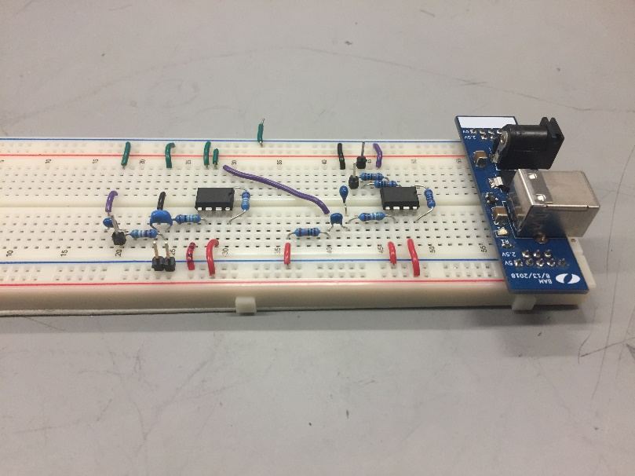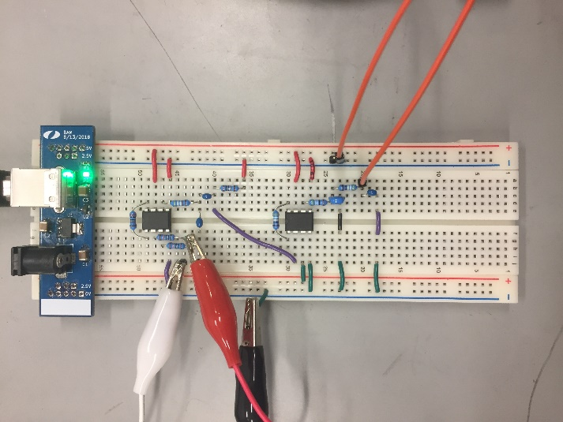

Bode Plot

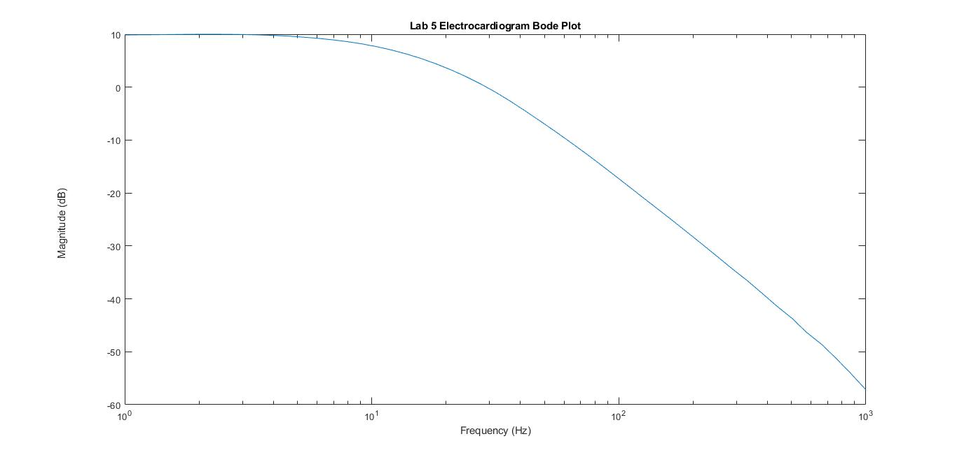

Heartbeat

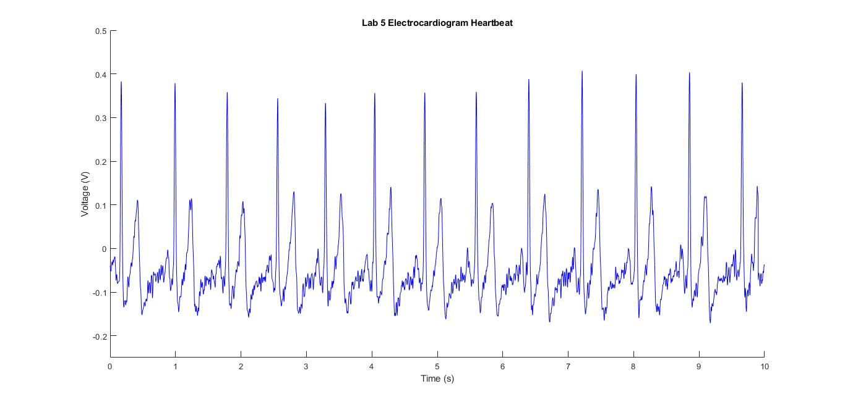

**Interpretation**

The Bode plot shows the signal being dampened as the frequency gets higher, which makes sense since a heartbeat is a low frequency, between about one and three hertz. This is because the circuit is a high-pass filter, meant to filter out the noise at higher frequencies since we only want to read heartbeats at low frequencies.

Also, the heartbeat looks approximately right compared to what typical heartbeat readings look like, with a high spike and then a low dip each cycle. The graph shows about 13 beats/10 seconds, which is about 78 beats/minute, which is a very reasonable and realistic heart rate.

As for error, since we are amplifying the signal with a gain of 51 then 21 (using the equation for Gain of the AD623 chip - G = 1 + 100kΩ / R, and the resistors used - 2kΩ and 4.99kΩ), so approximately a thousand fold, working backwards tells us that the original signal was less than a thousandth of a volt. Even though we used capacitors to filter out the higher frequencies and amplified the signal to gain better resolution, I still had to stay very still and not move my arms to get a consistent signal reading. This shows that my circuit was very sensitive to disruption.